# K-Nearest Neighbors

**Instructions:**

Please share your answers filled in-line in the word document. Submit code separately wherever applicable.

Please ensure you update all the details:

**Name: Anandakrishnan k v ;;;;;;;; Batch ID:**19042021

**Topic: K-Nearest Neighbors**

1. **Business Problem**

A glass manufacturing plant uses different earth elements to design new glass materials based on customer requirements. For that, they would like to automate the process of classification as it’s a tedious job to manually classify them. Help the company achieve its objective by correctly classifying the glass type based on the other features using KNN algorithm.

1. **Model Building**
   1. **Build the model on the scaled data (try multiple options).**
   2. **Perform KNN and use cross validation techniques to get optimum K value.**
   3. **Train and test the model and perform cross validation techniques. Compare accuracies, precision and recall and explain them in the documentation.**
   4. **Briefly explain the model output in the documentation.**

**Python Code:-**

import pandas as pd

import numpy as np

import seaborn as sns

import matplotlib.pyplot as plt

import seaborn as sn

# load the data set

glass = pd.read_csv("C://Users//user//Downloads//knn//glass.csv")

glass.shape

glass1 = glass.copy(deep=True)

###### Null value Treatment ########

glass1.isna().sum() ## no null values

###### Summary of the data set ####

glass1.columns

glass1.describe()

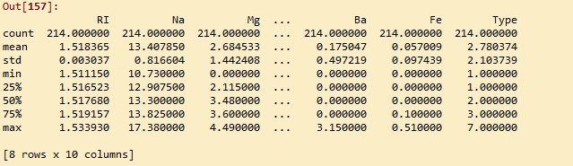

####### Outlier Treatment ########

# Boxplots

glass_bx_input = glass1.iloc[:, 0:9] ## except output column

for i in glass_bx_input.columns:

sns.boxplot(glass_bx_input[i].dropna())

plt.show() ## combined boxplot not showig any outliers

############ Zero variance analysis #############

glass1.shape

## importing ###

from sklearn.feature_selection import VarianceThreshold

# Feature selector that removes all low-variance features that meets the variance threshold limit

var_thres = VarianceThreshold(threshold=0) # Threshold is subjective.

var_thres.fit(glass1) ### fit the var_thres to data set

# Generally we remove the columns with zero variance, but i took thresold value 0 (Near Zero Variance)

var_thres.get_support() ### it giving an array out, where zero variant column treat as False value. we already fit var_thres to data set. so it gives corresponding information on data set

glass1.columns[var_thres.get_support()] ## non-zero variant column names

constant_columns = [column for column in glass1.columns if column not in glass1.columns[var_thres.get_support()]]

print(len(constant_columns)) ### number of zero variant variables

# since number of zero variant columns = 0 ==> none of the variables or column having zero variant property ; so directy going for further analysis without doing any zero variant treatment

# Normalization function

def norm_func(i):

x = (i-i.min()) / (i.max()-i.min())

return (x)

# Normalized data frame (except output column)

wbcd_n = norm_func(glass1.iloc[:, 0:9])

wbcd_n.describe()

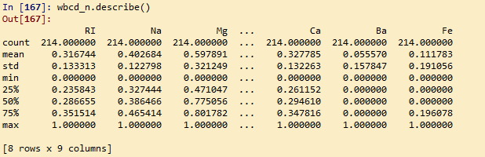

# univariate & byvariate plot after normalisation

sn.pairplot(glass1.iloc[:, 0:9])

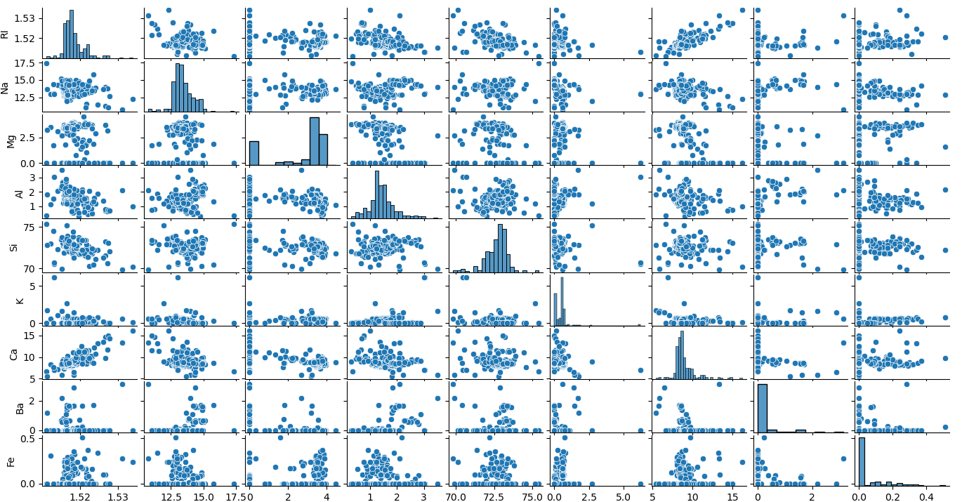

X = np.array(wbcd_n.iloc[:,:]) # Predictors

Y = np.array(glass1['Type']) # Target

# train & test split

from sklearn.model_selection import train_test_split

X_train, X_test, Y_train, Y_test = train_test_split(X, Y,stratify= Y, test_size = 0.2) ## proportion of output labels should be same

# KNeighborsClassifier

from sklearn.neighbors import KNeighborsClassifier

knn = KNeighborsClassifier(n_neighbors = 3) #consider 3 nearest neighbors

knn.fit(X_train, Y_train)

pred = knn.predict(X_test)

pred

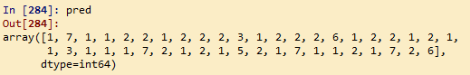

# Evaluate the model

from sklearn.metrics import accuracy_score

print(accuracy_score(Y_test, pred))

C:\Users\user\Downloads\knn\paint.png

from sklearn.metrics import classification_report, confusion_matrix

print(classification_report(Y_test, pred))

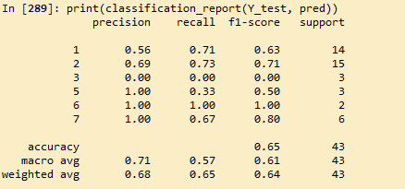

print(confusion_matrix(Y_test, pred))

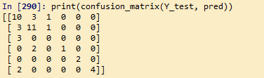

Predictions on Type ‘1’ glass falls more in other Types( 2,3 & 7)

# evaluation on train data

pred_train = knn.predict(X_train)

print(accuracy_score(Y_train, pred_train))

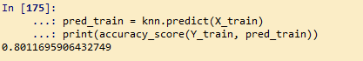

print(confusion_matrix(Y_train, pred_train))

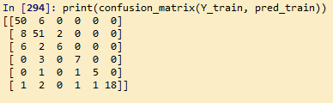

Compare to test prediction in train prediction happened more mis_classification. Especially for type “2” glasses

# creating empty list variable

acc = []

train_ac_value = []

test_ac_value = []

k_value = []

# running KNN algorithm for 3 to 50 nearest neighbours(odd numbers) and

# storing the accuracy values

for i in range(3,50,2):

neigh = KNeighborsClassifier(n_neighbors=i)

neigh.fit(X_train, Y_train)

train_acc = np.mean(neigh.predict(X_train) == Y_train)

test_acc = np.mean(neigh.predict(X_test) == Y_test)

acc.append([train_acc, test_acc])

train_ac_value.append(train_acc)

test_ac_value.append(test_acc)

k_value.append(i)

# accuracy table for different k value

accuracy_table = pd.DataFrame(columns=["k_value","train_score", 'test_score',"difference_square"])

difference=[]

error=[]

l = len(acc)

for i in range(l):

difference = train_ac_value[i]- test_ac_value[i]

error.append(difference*difference) ## to get the minimum value of error in magnitude by eliminating -ve sign

accuracy_table.k_value = pd.Series(k_value)

accuracy_table.train_score = pd.Series(train_ac_value)

accuracy_table.test_score = pd.Series(test_ac_value)

accuracy_table.difference_square = pd.Series(error)

accuracy_table.head(6)

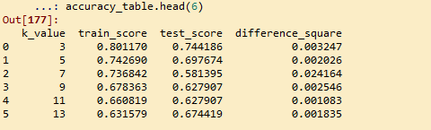

accuracy_table.describe() ## k = 3 for least difference in train & test accuracy

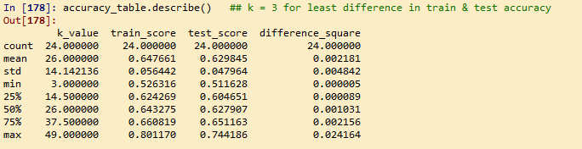

# graphical representaion of train & test accuracy with different k value

import matplotlib.pyplot as plt # library to do visualizations

# train accuracy plot

plt.plot(np.arange(3,50,2),[i[0] for i in acc],"ro-")

# test accuracy plot

plt.plot(np.arange(3,50,2),[i[1] for i in acc],"bo-")

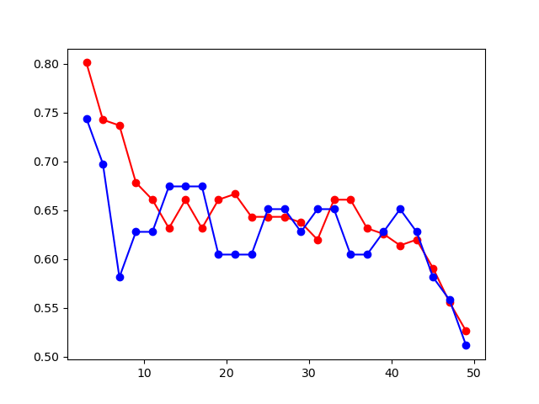

# model for k = 39

knn = KNeighborsClassifier(n_neighbors = 39) #consider 39 nearest neighbors

knn.fit(X_train, Y_train)

pred = knn.predict(X_test)

print(classification_report(Y_test, pred)) ## test acc= 65

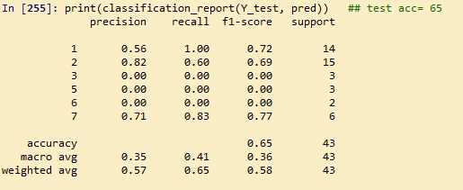

pred_train = knn.predict(X_train) # evaluation on train data

print(classification_report(Y_train, pred_train)) ## test acc= 62 ==> least acc diiference

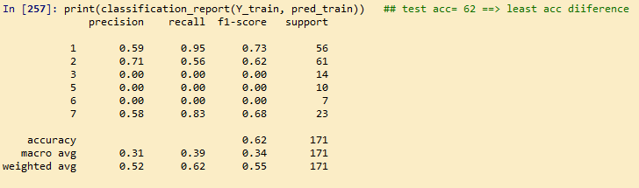

### checking accuracy while applying cross validation

from sklearn.model_selection import cross_val_score

X_train, X_test, Y_train, Y_test = train_test_split(X, Y, stratify= Y, test_size = 0.2) ## proportion of output labels would be sames for each split

cross_val_score(KNeighborsClassifier(n_neighbors=(3)), X_train, Y_train, cv=4)

C:\Users\user\Downloads\knn\paint.png

cross_val_score(KNeighborsClassifier(n_neighbors=(3)), X_train, Y_train,cv=4).mean() # mean score

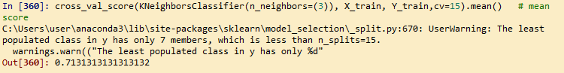

Q2)

**Business Problem**

A National Park in India is dealing with the problem of segregation of its species based on the different attributes they have. Build a KNN model to automatically classify new species. Explain any inferences you draw in the documentation.

**Python Code:-**

import pandas as pd

import numpy as np

import seaborn as sns

import matplotlib.pyplot as plt

# load the data set

zoo = pd.read_csv("C://Users//user//Downloads//knn//Zoo.csv")

zoo.shape

zoo1 = zoo.copy(deep=True)

###### Null value Treatment ########

zoo1.isna().sum() ## no null values

zoo1 = zoo1.iloc[:, 1:] # Excluding animal name column ==> less informative

###### Summary of the data set ####

zoo1.columns

zoo1.describe()

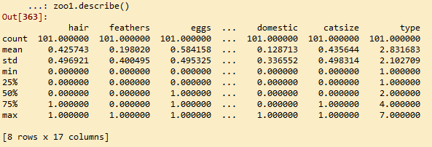

####### Outlier Treatment ########

# Boxplots

zoo_bx_input = zoo1.iloc[:, 0:16] ## except output column

for i in zoo_bx_input.columns:

sns.boxplot(zoo_bx_input[i].dropna())

plt.show() ## combined boxplot not showig any outliers

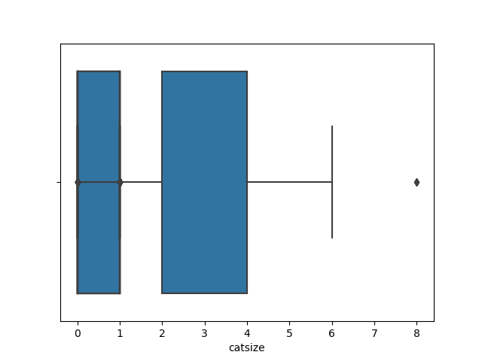

############ Zero variance analysis #############

zoo1.shape

## importing ###

from sklearn.feature_selection import VarianceThreshold

# Feature selector that removes all low-variance features that meets the variance threshold limit

var_thres = VarianceThreshold(threshold=0) # Threshold is subjective.

var_thres.fit(zoo1) ### fit the var_thres to data set

# Generally we remove the columns with zero variance, but i took thresold value 0 (Near Zero Variance)

var_thres.get_support() ### it giving an array out, where zero variant column treat as False value. we already fit var_thres to data set. so it gives corresponding information on data set

zoo1.columns[var_thres.get_support()] ## non-zero variant column names

constant_columns = [column for column in zoo1.columns if column not in zoo1.columns[var_thres.get_support()]]

print(len(constant_columns)) ### number of zero variant variables

# since number of zero variant columns = 0 ==> none of the variables or column having zero variant property ; so directy going for further analysis without doing any zero variant treatment

# Normalization function

def norm_func(i):

x = (i-i.min()) / (i.max()-i.min())

return (x)

# Normalized data frame (except output)

wbcd_n = norm_func(zoo1.iloc[:, 0:16])

wbcd_n.describe()

# univariate & byvariate plot after normalisation

sn.pairplot(zoo1.iloc[:, 0:16])

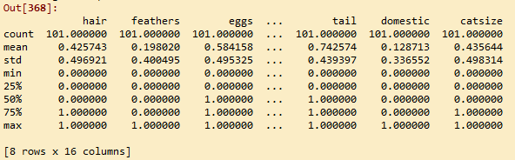

# univariate & byvariate plot after normalisation

sn.pairplot(zoo1.iloc[:, 0:16])

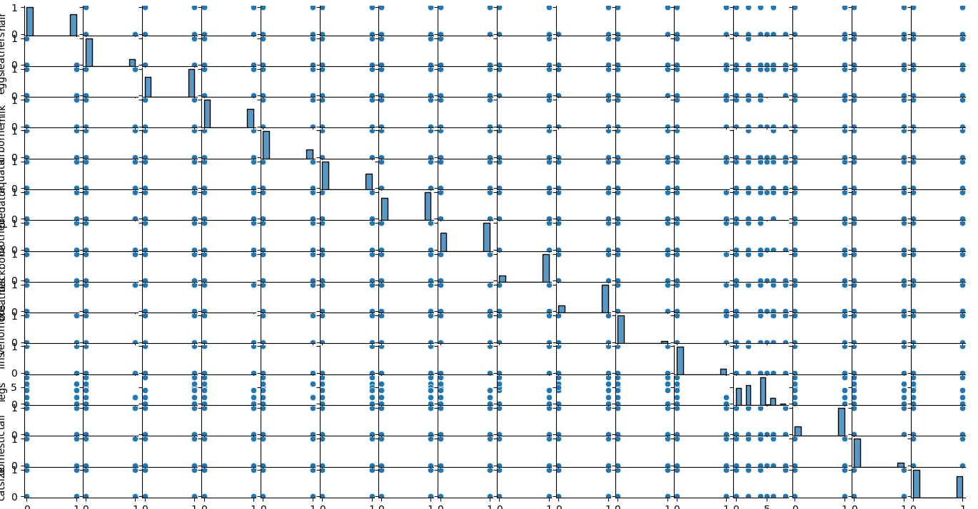

# Differentiate predictors (input variables) & targeters(output variable)

X = np.array(wbcd_n.iloc[:,:]) # Predictors

Y = np.array(zoo1['type']) # Target

# train & test split

from sklearn.model_selection import train_test_split

X_train, X_test, Y_train, Y_test = train_test_split(X, Y, test_size = 0.2)

# KNeighborsClassifier

from sklearn.neighbors import KNeighborsClassifier

knn = KNeighborsClassifier(n_neighbors = 5) #consider 5 nearest neighbors

knn.fit(X_train, Y_train)

pred = knn.predict(X_test)

pred

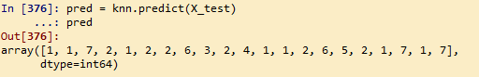

# Evaluate the model

from sklearn.metrics import classification_report, confusion_matrix

from sklearn.metrics import accuracy_score

print(accuracy_score(Y_test, pred))

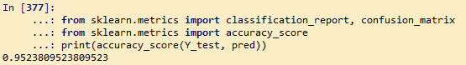

print(classification_report(Y_test, pred))

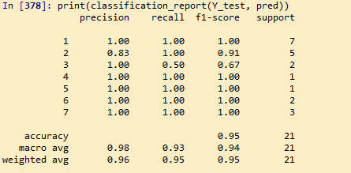

print(confusion_matrix(Y_test, pred))

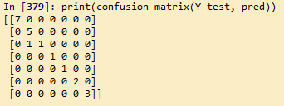

Misclassification on test data prediction happeneds only for Type “2” species, that’s even only one

# error on train data

pred_train = knn.predict(X_train)

print(accuracy_score(Y_train, pred_train))

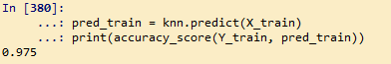

print(confusion_matrix(Y_train, pred_train))

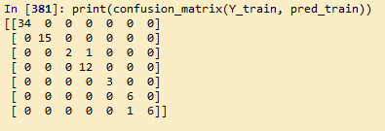

# creating empty list variable

acc = []

train_ac_value = []

test_ac_value = []

k_value = []

# running KNN algorithm for 3 to 50 nearest neighbours(odd numbers) and

# storing the accuracy values

for i in range(3,50,2):

neigh = KNeighborsClassifier(n_neighbors=i)

neigh.fit(X_train, Y_train)

train_acc = np.mean(neigh.predict(X_train) == Y_train)

test_acc = np.mean(neigh.predict(X_test) == Y_test)

acc.append([train_acc, test_acc])

train_ac_value.append(train_acc)

test_ac_value.append(test_acc)

k_value.append(i)

# accuracy table for different k value

accuracy_table = pd.DataFrame(columns=["k_value","train_score", 'test_score',"difference_square"])

difference=[]

error=[]

l = len(acc)

for i in range(l):

difference = train_ac_value[i]- test_ac_value[i]

error.append(difference*difference) ## to get the minimum value of error in magnitude by eliminating -ve sign

accuracy_table.k_value = pd.Series(k_value)

accuracy_table.train_score = pd.Series(train_ac_value)

accuracy_table.test_score = pd.Series(test_ac_value)

accuracy_table.difference_square = pd.Series(error)

accuracy_table.head(6)

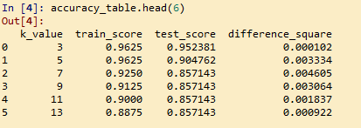

accuracy_table.describe() ## k = 39 for least difference in train & test accuracy

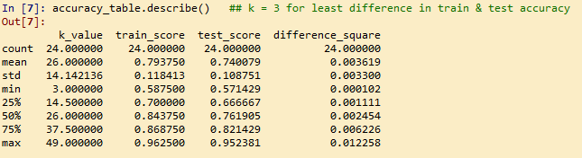

# graphical representaion of train & test accuracy with different k value

import matplotlib.pyplot as plt # library to do visualizations

# train accuracy plot

plt.plot(np.arange(3,50,2),[i[0] for i in acc],"ro-")

# test accuracy plot

plt.plot(np.arange(3,50,2),[i[1] for i in acc],"bo-")

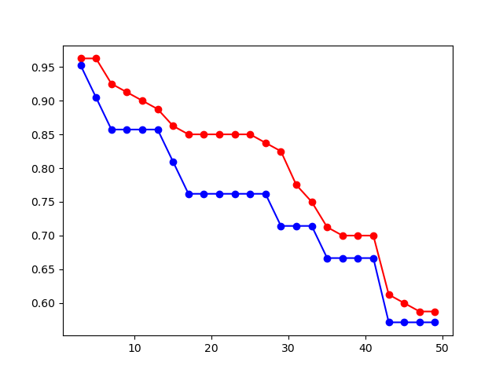

# model for k = 3

knn = KNeighborsClassifier(n_neighbors = 3) #consider 3 nearest neighbors

knn.fit(X_train, Y_train)

pred = knn.predict(X_test)

print(classification_report(Y_test, pred)) ## test acc= .95

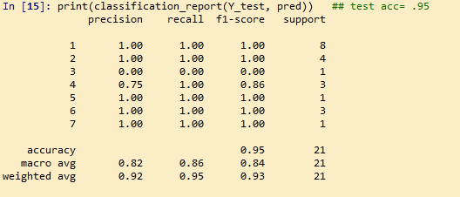

pred_train = knn.predict(X_train) # evaluation on train data

print(classification_report(Y_train, pred_train)) ## test acc= .96 ==> least acc diiference

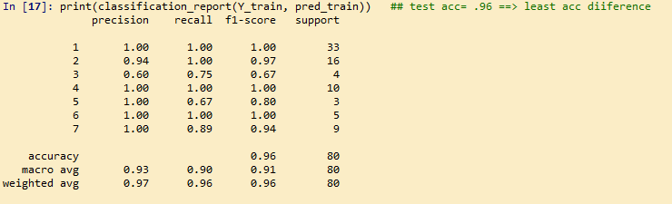

### checking accuracy while applying cross validation

from sklearn.model_selection import cross_val_score

X_train, X_test, Y_train, Y_test = train_test_split(X, Y, stratify= Y, test_size = 0.2) ## proportion of output labels would be sames for each split

cross_val_score(KNeighborsClassifier(n_neighbors=(3)), X_train, Y_train, cv=4)

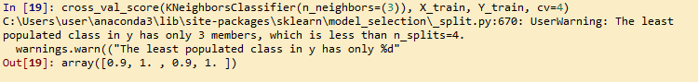

cross_val_score(KNeighborsClassifier(n_neighbors=(3)), X_train, Y_train,cv=15).mean() # mean score

